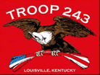
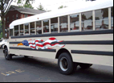
TROOP 243
November 1st, 2016
Boy Scouts of America
Chartered by St. John Paul II Catholic Church
3044 Hikes Lane Louisville, Ky 40220
3521 Goldsmith Lane http://www.troop243.com

Troop 243 Outings & Activities – Among other things in November, Dakota Quint’s Eagle Court of honor is on Saturday, November 12 at 2PM. Flier handout Scouting for Food is on Saturday, November 12th. Our troop will return the following week, Saturday, November 19th.

Troop and Patrol Meetings on Wednesdays - All are welcome. Scouts in Field/Class A uniforms are expected for all troop meetings while class B uniforms are ok for patrol meetings. Except where noted, all meetings are held at St. St. John Paul II’s Hikes Lane Campus. SERVICE PATROLS should arrive 15 minutes early to set up for the meeting.

November 2nd, 7:00 PM – Troop Meeting - Emergency Prep
November 9th, 7:00 PM – Patrol Meetings - Emergency Prep Competition
November 16th, 7:00 PM – Troop Meeting - Emergency Prep
November 23rd, 7:00 PM – Troop Game Night @ Gallagher Hall
November 30th, 7:00 PM – Court of Honor

Emergency Preparedness Merit Badge – The E Prep merit badge is this month’s merit badge. It is an eagle required merit badge and can help get you on your way to Eagle Scout. It will also prepare you for an emergency situation like a tornado. There is a patrol competition on November 9th which will test the scout’s E Prep skills.

Troop Leadership Meetings – Troop Leadership Meetings will be held on the regular days this month. The PLC meets on Sunday, November 27th 4PM while the adults will meet from 7-9PM Monday November 28th. Everyone is invited.

October Fun and Celebrations!

Last month, our Troop went to E.P. Tom Sawyer State Park on October 14 to celebrate 100 years of scouting in the Lincoln Heritage Council.
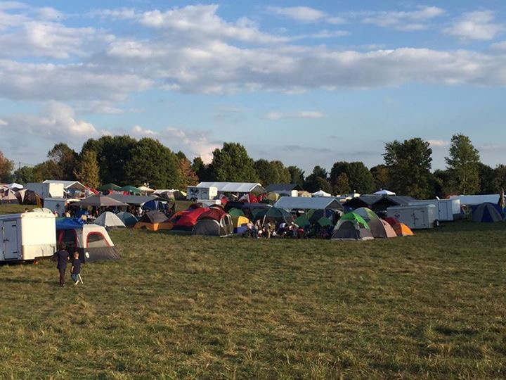

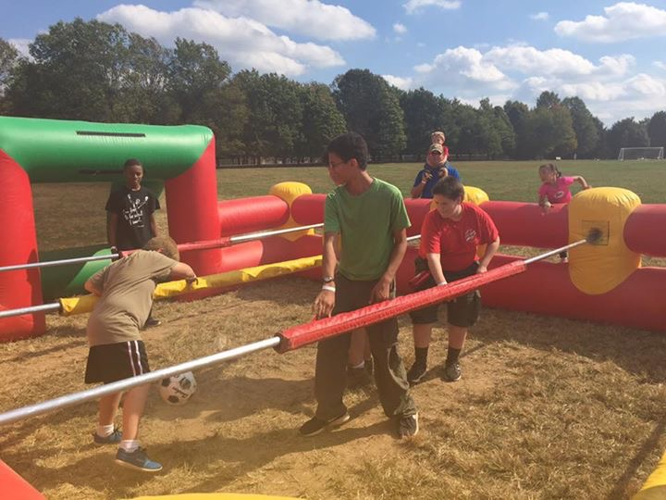
There were many fun activities including human foosball, rock climbing, and paintball.

Our troop attended Mass celebrated by Archbishop Kurtz on Sunday morning.
